Name, Date, Period_____________________________

Virtual Lab – Vectors & Vector Operations
Setup
- Make sure your calculator is set to degrees and not radians. Sign out a laptop and power cord. Plug in the laptop and leave it plugged in and on.
- Do a Google search for “PhET” and then go to the PhET website.
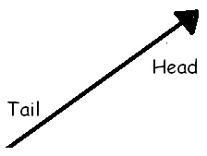
- From the menu at the left, click “Math Tools” and then select the Vector Addition simulation.
- Once you get to the Vector Addition page, there should be a green button below the picture that says “Run Now!” Click this button.
- In the basket at the top right, you can drag out a vector arrow. If you ever want to get rid of a vector, drag it to the trash can at the bottom right. If you want to start over, click “Clear All.”
- You can adjust the direction and length of the arrow by click-dragging the arrow head. Play with this until you are comfortable.
- Check all the boxes at the top right except for “sum.” (these will show grid, vector length, and angles)

Part A: 3-4-5 Triangle
- Drag out a vector, and move it until the tail is located at the origin. Click on the head of the vector, and drag it until it is completely horizontal, points to the right, and has a magnitude ($\overset{⃑}{a}$) of 20.
- Look at the chart at the top of the page. Here is an explanation of what each number represents:
  - $\overset{⃑}{a}$represents the length of the arrow. This is usually called the magnitude of the vector.
  - Θ represents the direction the arrow points. This is simply called the direction of the vector. The magnitude AND direction will completely define a vector.
  - a_{x} is called the X-component of the vector. This is the length of the vector in the X-direction only.
$$\overset{⃑}{a}$$ | θ | a_{x} | a_{y}
20.0 | 0.0 | 20.0 | 0.0
  - a_{y} is called the Y-component of the vector. This is the length of the vector in the Y-direction only.
- For the first vector you dragged out, fill in the chart at right.

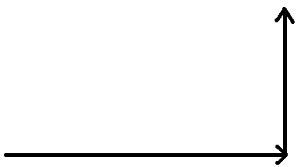
$$\overset{⃑}{b}$$ | θ | b_{x} | b_{y}
15.0 | 90.0 | 0.0 | 15.0
- Now, drag out a second vector $\overset{⃑}{b}$and place its tail at the head of the first, as shown at right. Adjust this second vector until it points vertically upward and has a length of 15. Fill in the table for this vector here:

- As you saw in the previous activity, if you were to walk this path, at the end you would be 25 units away from the origin. You can show this by clicking the button that says Sum. A new dark blue vector $\overset{⃑}{s}$ should pop up. This represents the vector sum, or resultant, of the first two arrows.

|s| | θ | s_{x} | s_{y}
25.0 | 36.9 | 20.0 | 15.0
- Drag this vector over so that the tail is at the origin, and use it to form the hypotenuse of a right triangle. Notice that the head of this vector ends exactly where the second vector ends. Click on the dark blue vector and fill in the chart for this vector here:

- ۞ Compare the s_{x} and s_{y} values to the values from questions #10 and #11. What do you notice about these values?
The values of s_{x} is equal to the magnitude of the vector as in question 10 while s_{y} is equal to the magnitude of the second vector as in question 11.
Part B: Single Vector, Magnitude 50
$$\overset{⃑}{a}$$ | θ | a_{x} | a_{y}
25.0 | 36.9 | 20.0 | 15.0
- Hit the Clear All button to erase the screen. Next, create a new $\overset{⃑}{a}$vector with an a_{x} of 20 and an a_{y} of 15. Fill in the chart for this vector here:

- ۞ Compare the chart values of this vector to those of the dark blue $\overset{⃑}{s}$ vector from #13. How do these values compare?

The values of this vector are equal to those of the resultant vector in #13.
- Next, click the button on the “Components” menu. This is a way to visualize any vector as a sum of horizontal and vertical components.

$$\overset{⃑}{a}$$ | θ | a_{x} | a_{y}
33.5 | 60.0 | 15.0 | 30.0
- Adjust this vector until it has an a_{x} value of 15 and an a_{y} value of 30. Fill in the chart for this vector:

- ۞ Has the magnitude of this vector changed, compared #15? If so, how?
The magnitude of the vector has increased to 33.5.

- ۞ Has the direction (that is, θ) of this vector changed, compared to #15? If so, how?

The direction has increased to 60˚
- ۝ Figure out a way to adjust the magnitude and direction of this vector until it has a magnitude of 25, just like before, but points in a different direction from the first two tries. Fill in the chart for this vector, and show your vector to your instructor.

$$\overset{⃑}{a}$$ | θ | a_{x} | a_{y}
25.0 | 53.1 | 15.0 | 20.0

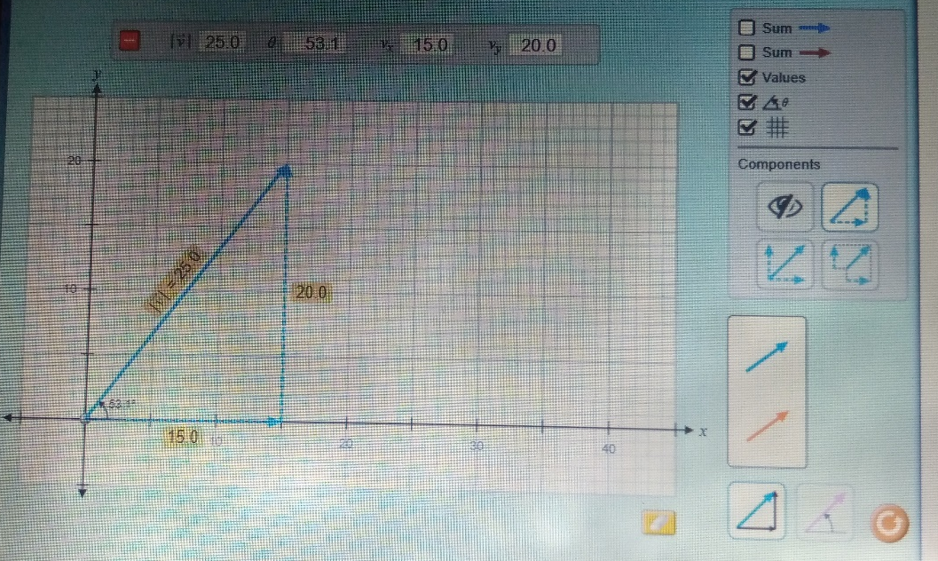

- Looking at this vector, it is easy to imagine a right triangle, made from a_{x}, a_{y} and$\overset{⃑}{|a|}$. In this case, $\overset{⃑}{|a|}$ would be the hypotenuse, and a_{x} & a_{y} would be the legs.
  - Show, using the Pythagorean Theorem, that |$\overset{⃑}{a}$|² = a_{x}² + a_{y}².
25² = 15² + 20²
625 = 225 + 400

  - Show, using SOHCAHTOA, that a_{x} = |$\overset{⃑}{a}$| cos θ.

25cosƟ = a_{x}
25cos53.1 = 15.01
  - Show, using SOHCAHTOA, that a_{y} = |$\overset{⃑}{a}$| sin θ.

25sinƟ = a_{y}
25sin53.1 = 19.99
- Clear All. Imagine a vector with magnitude |$\overset{⃑}{a}$| = 28 and angle θ = 45º.

  - ۝ Use SOHCAHTOA to determine the X- And Y- components (that is, find a_{x} and a_{y}). Show your work to your instructor.

X = 28cos45 = 19.79
Y = 28sin45 = 19.79

  - Check your answer by constructing this vector.

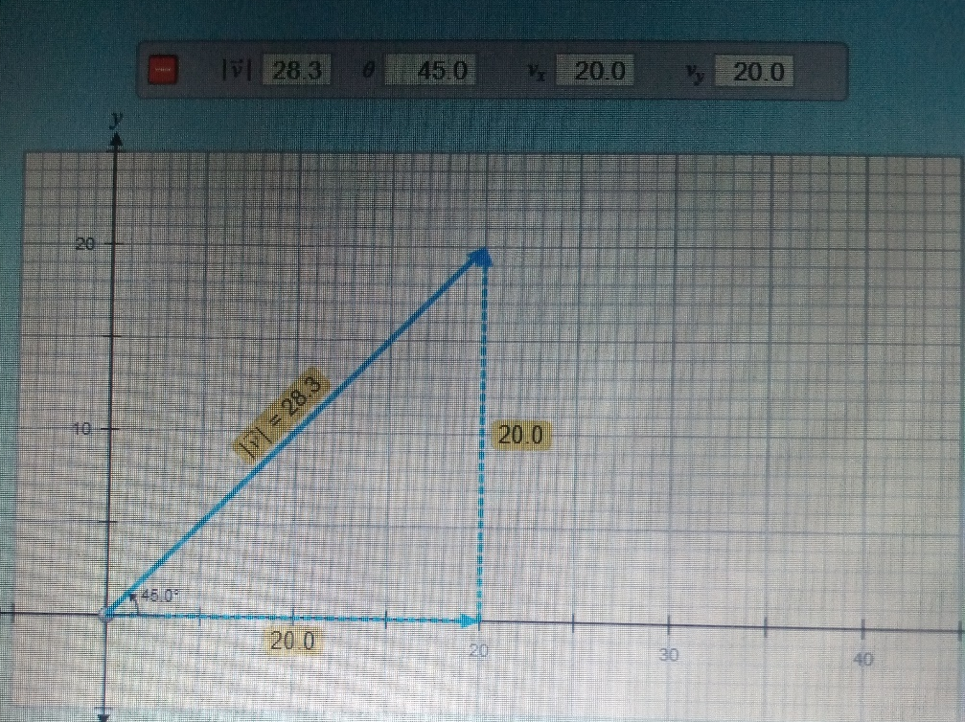
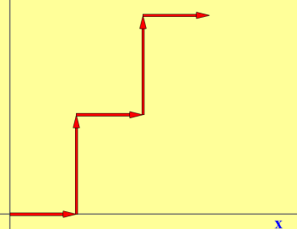
Part C – Several Vectors (Switch to “Lab” version of sim)

- Re-open the vector sim, but this time choose the “lab” version. Create 5 vectors of the same color, as shown at right. The length of each of the horizontal vectors should be 5, and the length of the vertical vectors should be 10.

- Click on the “Show Sum” button. Fill in the chart for this resultant, or sum, vector.
$$\overset{⃑}{s}$$ | θ | s_{x} | s_{y}
25.0 | 53.1 | 15.0 | 20.0

- ۝ A useful way to keep track of vector sums is to create a chart. Complete the chart below, using the 5 vectors you’ve constructed, and then add the columns to get the sums. Show your instructor when finished.
Vector # | v_{x} | v_{y}
1 | 5 | 0
2 | 0 | 10
3 | 5 | 0
4 | 0 | 10
5 | 5 | 0
SUM | 15 | 20
- ۞ How do the v_{x} and v_{y} sums from the previous chart compare to the s_{x} and s_{y} values from question #25?
The sum of vectors in the x direction is 15, which is equal to S_{x} in #25.
The sum of vectors in the y direction is 20, which is equal to S_{y} in #25.

- ۝ Using the Pythagorean Theorem, determine the resultant |$\overset{⃑}{s}$| value, which is the hypotenuse of a triangle with s_{x} and s_{y} as its legs. Compare this number to the |$\overset{⃑}{s}$| value from #25. Show instructor when finished.

Hypotenuse = $√$(15² + 20²) = 25

- Clear All. Construct the following 4 vectors and add them with the “head-to-tail” method:
- $\overset{⃑}{v}$ = 10, θ = 0º (start this one at the origin)
- $\overset{⃑}{v}$ = 10, θ = 90º
- $\overset{⃑}{v}$ = 10, θ = 180º (or -180º)
- $\overset{⃑}{v}$ = 10, θ = 270º (or -90º)

$$\overset{⃑}{s}$$ | θ | s_{x} | s_{y}
0.0 | 0.0 | 0.0 | 0.0
- What is the sum (or resultant) of these vectors?

$$\overset{⃑}{s}$$ | θ | s_{x} | s_{y}
10.0 | 0.0 | 10.0 | 0.0
- What is the sum of these vectors if the first vector is 10 units long rather than 20?

- Answer extension questions on the next page.
Extension Questions

- A student, following instructions on her treasure map, starts at the origin and walks the following routes:
18 meters North (θ = 90º)
5 meters West (θ = 180º)
9 meters South (θ = 270º or -90º)
17 meters East (θ = 0º)

  - Fill in the chart below, which represents the horizontal and vertical components of the routes. Also determine the X and Y sums.

Vector # | v_{x} | v_{y}
1 | 0 | 18
2 | 5 | 0
3 | 0 | 9
4 | 17 | 0
SUM | 22 | 27
  - After the student has finished walking, what is her horizontal displacement? (v_{x} sum)

22 meters
  - What is her vertical displacement? (v_{y} sum)

27 meters
  - Using the Pythagorean Theorem, and your answers from (b) and (c), how far is she from the origin? (In other words, what is her resultant |R|?)

17-5 = 12
18-9 = 9
12² + 9² = 225
|R| = $\sqrt{225}=$15

  - Using SOHCAHTOA, what is her direction, as measured from the origin? (In other words, what is θ?)
Ɵ = cos⁻¹ (12/15) = 36.86

- A model airplane is flying North with a velocity of 15 m/s. A strong wind is blowing East at 12 m/s.

  - What is the airplane’s resultant speed (magnitude of velocity vector)?

19.2

  - What is the airplane’s heading (direction of velocity vector)?
51.3˚

